Sakib Chowdhury
Student #: 501112572

CPS510 - Section 4
TA: Wael Shabana
Prof: A. Abhari

Assignment 4 - Part 2

View 1

This view shows all bookings that have customers.

It joins the Employee table with the Booking Table to show an employee’s name in the HandledBy column.

It also shows the list of all customers associated with this booking in the Customers column.
These customers are ordered by their name, so it is alphabetical ordering.

CREATE OR REPLACE VIEW VIEW_BOOKING_WITH_CUSTOMERS AS
SELECT
b.BookingID,
TO_CHAR(b.CheckIn, 'YYYY-MM-DD') AS CheckIn,
TO_CHAR(b.CheckOut, 'YYYY-MM-DD') AS CheckOut,
b.Status,
b.NumGuests,
b.TotalPrice,
e.EmpName AS HandledBy,
LISTAGG(c.CusName, ', ') WITHIN GROUP (ORDER BY c.CusName) AS Customers
FROM Booking b
JOIN Employee e
ON e.EmployeeID = b.EmployeeID
LEFT JOIN Booking_Customer bc
ON bc.BookingID = b.BookingID
LEFT JOIN Customer c
ON c.CustomerID = bc.CustomerID
GROUP BY
b.BookingID, b.CheckIn, b.CheckOut, b.Status, b.NumGuests, b.TotalPrice, e.EmpName;
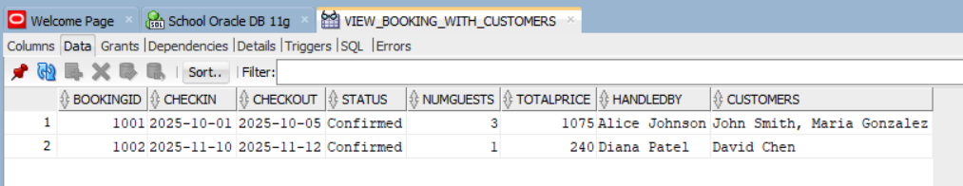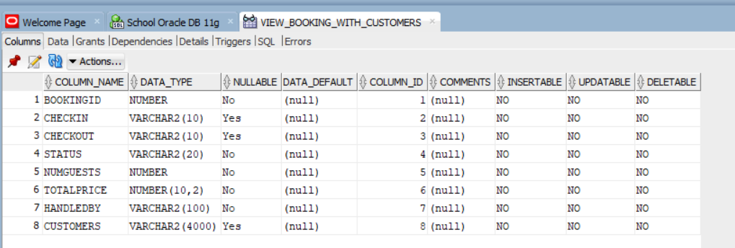

View 2
This view shows all active customers. Meaning customers that have a booking associated with them.

It joins the Customer table with the Booking_Customer table.

It also uses the DISTINCT keyword, so that if a customer is associated with more than one booking, they will NOT show multiple times in different rows. Rather, they will just show up once.

CREATE OR REPLACE VIEW VIEW_ACTIVE_CUSTOMERS AS
SELECT DISTINCT
c.CustomerID,
c.CusName,
c.Email
FROM Customer c
JOIN Booking_Customer bc
ON bc.CustomerID = c.CustomerID;

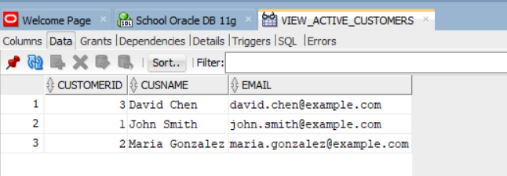
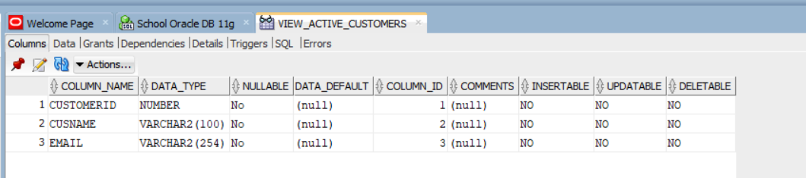

View 3

This view shows which services add ons are associated with a booking, and which customers for which the service is for.

CREATE OR REPLACE VIEW VIEW_BOOKING_SERVICES AS
SELECT
b.BookingID,
TO_CHAR(b.CheckIn,'YYYY-MM-DD') AS CheckIn,
TO_CHAR(b.CheckOut, 'YYYY-MM-DD') AS CheckOut,
e.EmpName AS EmployeeName,
c.CusName AS CustomerName,
s.ServiceName,
sb.Quantity,
sb.TotalPrice
FROM Booking b
JOIN Employee e ON e.EmployeeID = b.EmployeeID
JOIN Booking_Customer bc ON bc.BookingID = b.BookingID
JOIN Customer c ON c.CustomerID = bc.CustomerID
JOIN Service_Booking sb ON sb.BookingID = b.BookingID
JOIN Service s ON s.ServiceID = sb.ServiceID;

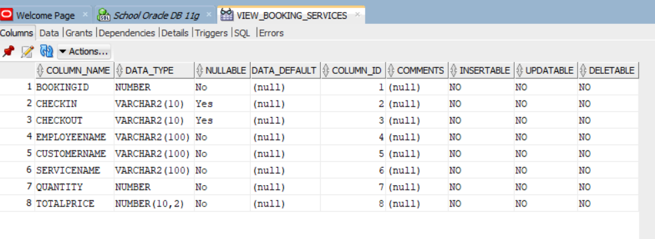
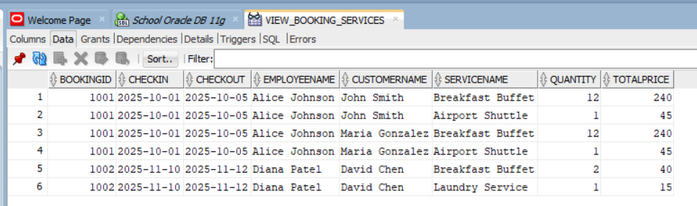

Queries

Query 1

Show all customers:
- CustomerID
- CusName
- Email
Order by their CusName, alphabetical order

SELECT CustomerID, CusName, Email
FROM Customer
ORDER BY CusName;

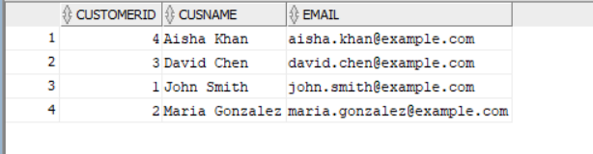

Query 2

Show all customers who have an IDTYPE = ‘Passport’
Show these columns:
- CustomerID
- CusName
- IdType

SELECT CustomerID, CusName, IDType
FROM Customer
WHERE IDType = 'Passport';

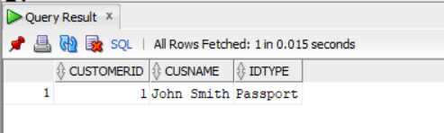

Query 3

Show all Rooms that have their status column = ‘Available’
Order these rooms by Price in ascending order
Show these columns:
- RoomNum, RoomType, Price

SELECT RoomNum, RoomType, Price
FROM Room
WHERE Status = 'Available'
ORDER BY Price;
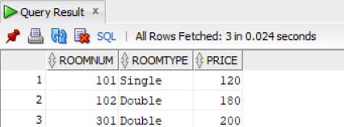

Query 4

Show the Rooms where the Price is greater than 150
Show these columns:
- RoomNum
- Floor
- RoomType
- Price
Order by price in descending order

SELECT RoomNum, Floor, RoomType, Price
FROM Room
WHERE Price > 150
ORDER BY Price DESC;

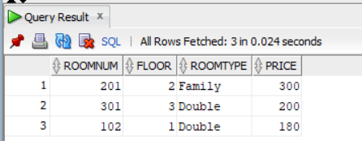

Query 5

Show all Employees whose salary is less than 50000 and order by ascending Salary
Show these columns:
- EmployeeID
- EmpName
- EmpRole
- Salary

SELECT EmployeeID, EmpName, EmpRole, Salary
FROM Employee
WHERE Salary < 50000
ORDER BY Salary;

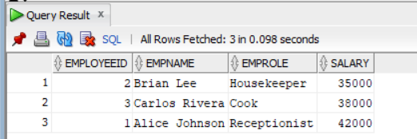

Query 6

Show all Bookings that have a status of ‘Confirmed’
Show these columns:
- BookingID, CheckIn, CheckOut, Status

SELECT BookingID, CheckIn, CheckOut, Status
FROM Booking
WHERE Status = 'Confirmed';

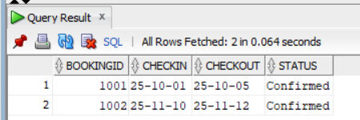

Query 7

Show all Bookings that have a status of ‘Cancelled’
Show these columns:
- BookingID
- CheckIn
- CheckOut
- Status

SELECT BookingID, CheckIn, CheckOut, Status
FROM Booking
WHERE Status = 'Cancelled';

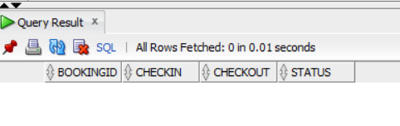

Query 8

Show Bookings and join the Employee table with the Booking table, so that we can show the name of the employee that handled a Booking.

SELECT b.BookingID, b.Status, e.EmpName AS HandledBy
FROM Booking b
JOIN Employee e
ON b.EmployeeID = e.EmployeeID
ORDER BY b.BookingID;

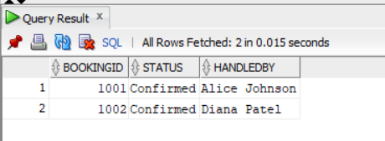

Query 9

Show bookings and the associated Customer Names

SELECT b.BookingID, c.CusName
FROM Booking b
JOIN Booking_Customer bc
ON b.BookingID = bc.BookingID
JOIN Customer c
ON c.CustomerID = bc.CustomerID
ORDER BY b.BookingID, c.CusName;

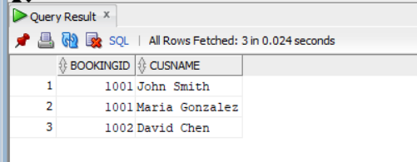

Query 10

Show Employees and the Customers they served.

SELECT DISTINCT e.EmpName, c.CusName
FROM Employee e
JOIN Booking b
ON e.EmployeeID = b.EmployeeID
JOIN Booking_Customer bc
ON bc.BookingID = b.BookingID
JOIN Customer c
ON c.CustomerID = bc.CustomerID
ORDER BY e.EmpName, c.CusName;

